**APEX COLLEGE**

**POKHARA UNIVERSITY**

**LAB REPORT OF**

**DOT NET TECHNOLOGY**

**LAB -FInal**

**Submitted By: Submitted To:**

**Remisha Maharjan Bishwomitra Adhikari**

**BCIS ‘Adware’ Ananta Pant**

**Roll no: 17**

**OBJECTIVE:-**

-Project API Testing via Postman

**THEORY:-**

**API** is a defined set of rules, which contains clearly defined methods of communication. API helps different software components to interact with each other. It involves testing the collection of APIs and checking if they meet expectations for functionality, reliability, performance, and security and returns the correct response. It is used to determine whether the output is well-structured and useful to another application or not, checks the response on basis of input (request) parameter, and checks how much time the API is taking to retrieve and authorize the data too.

**Postman**is an application for testing APIs, by sending request to the web server and getting the response back.

* It allows users to set up all the headers and cookies the API expects, and checks the response.
* Productivity can be increased using some of the Postman features, which are listed below.

A test in Postman is fundamentally a JavaScript code, which run after a request is sent and a response has been received from the server.

**CODE:-**

1. **Customer create**

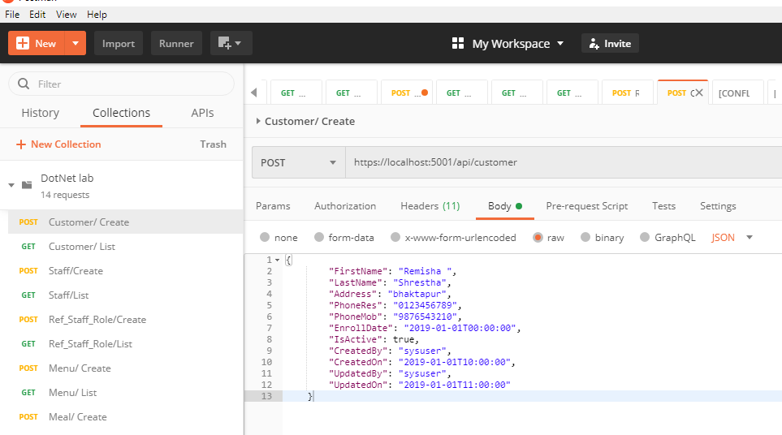

1. **Customer List**

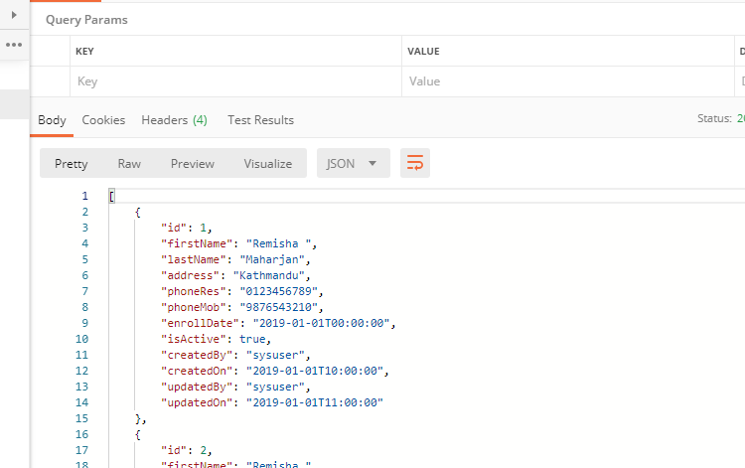

1. **Customer Edit**

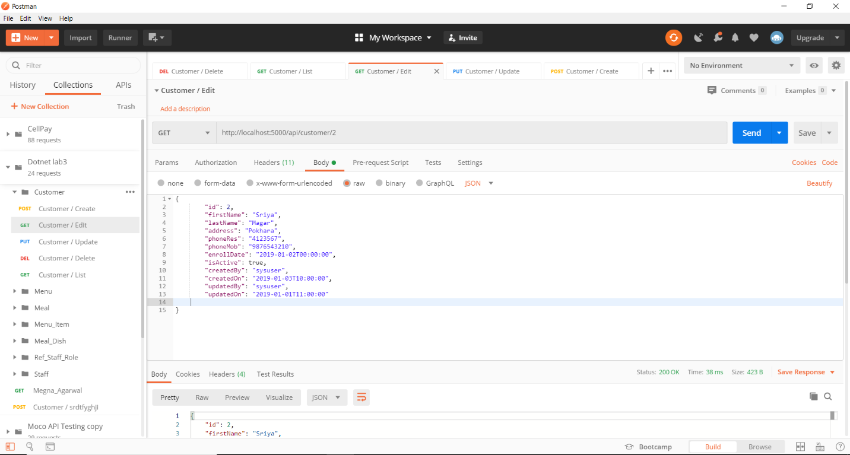

1. **Customer Update**

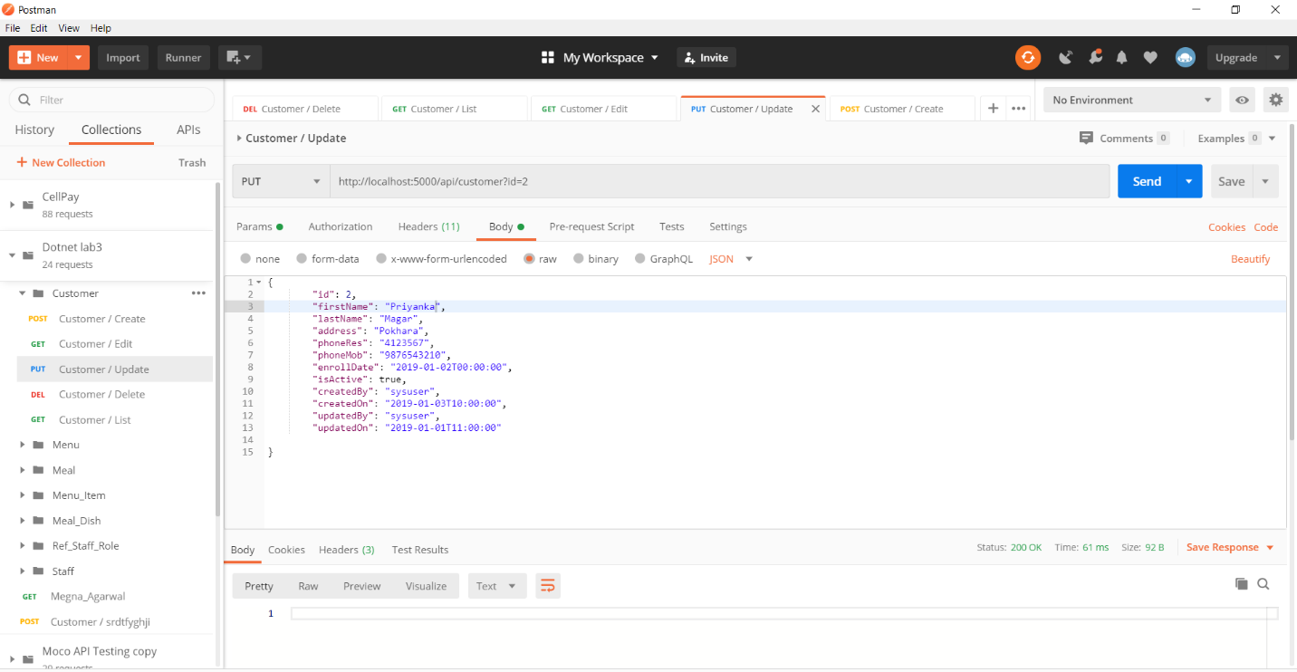

1. **Customer Updated Result**

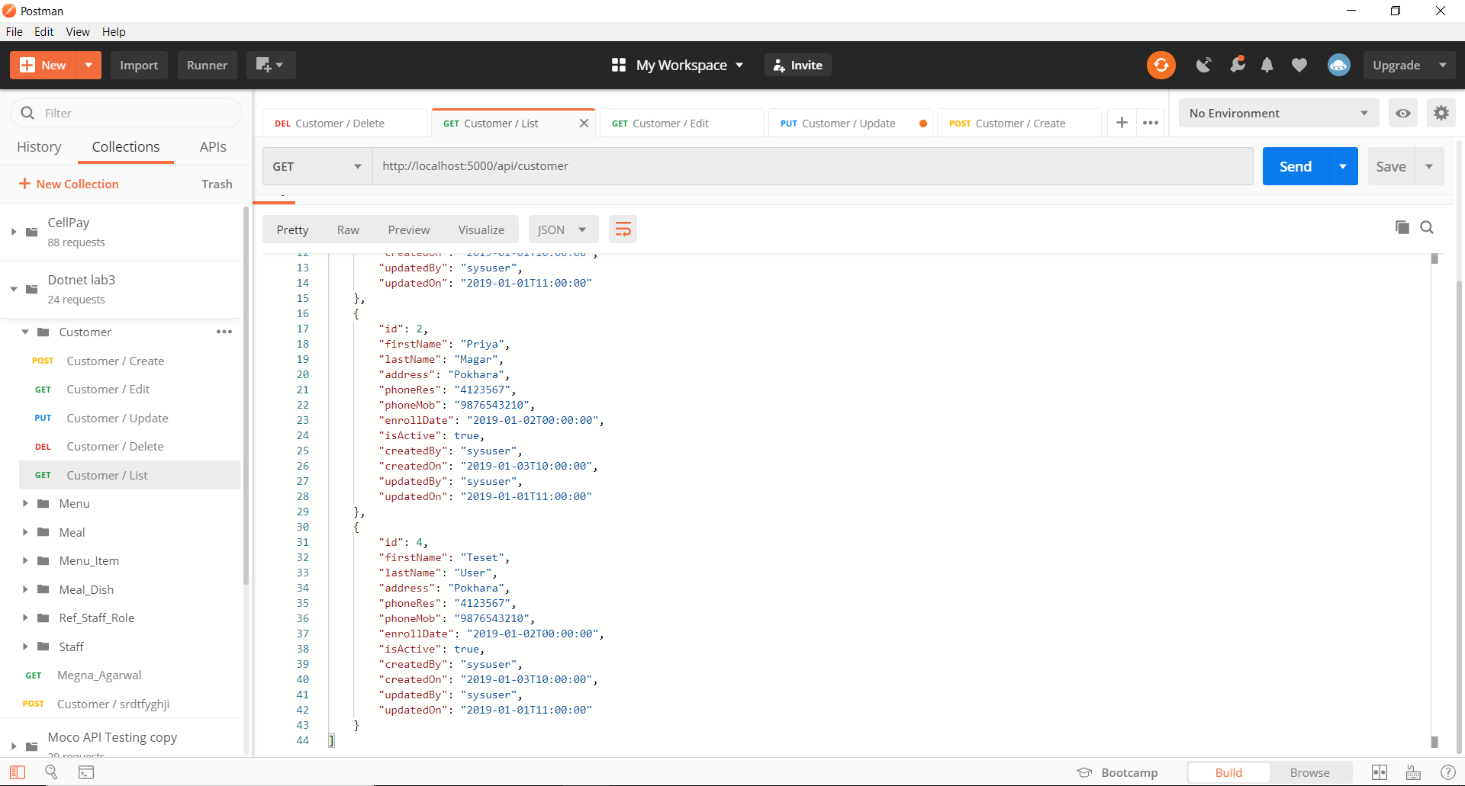

1. **Customer Delete**

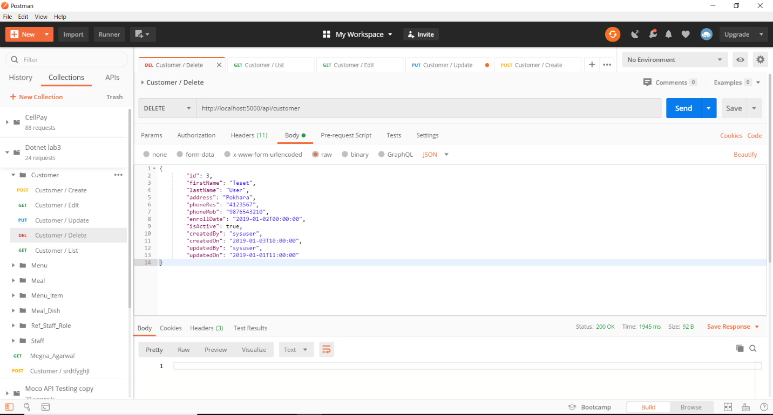

**Conclusion:**

In final lab we learned to run the project via postman.